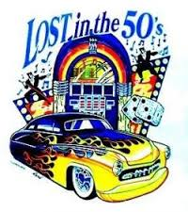

CMU - RANGOS Hall

5000 Forbes Avenue (free parking)

## **Saturday, September 13**

# 7:00 pm Waltz lesson by Kent Berkey

# 8:00 – 11:00 pm DJ John Siefken

www.usadancepgh.com

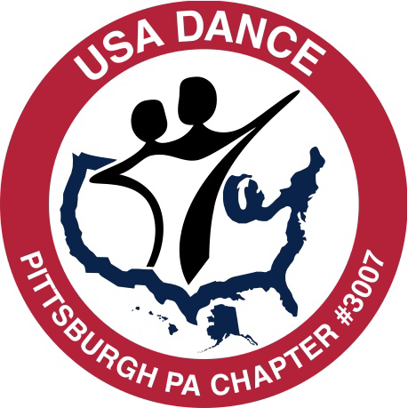

Members $10

Non-Members $15

Students with ID $5

Prize for

Best Dressed

**SOCK HOP**