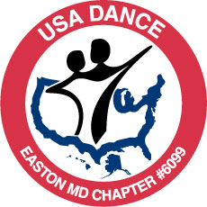
USA DANCE EASTON MD CHAPTER #6099

DANCE

BALLROOM - LATIN - SWING - COUNTRY WESTERN - HUSTLE
& MORE

YMCA of the Chesapeake, 202 Peachblossom Road, Easton, MD

.
Saturday, September 7 , 2013

7:15pm-8:00pm—Hustle lesson with Aggie Beletsky
(Included with price of admission).

8:00pm-10:00pm—Dancing to music by DJ Aggie Beletsky

TICKETS SOLD AT THE DOOR
$12.00 General Admission
$10.00—USA Dance Members and YMCA Members with current membership card
and under 21 with valid ID.
(Join USA Dance on the night of the dance and your admission will be free).

…..want to dance but don’t know how?---we can fix that

Couples, Singles, Dancers of all levels WELCOME
Dressy casual attire. Smoke and alcohol free.
Ladies, no street shoes with spike heels, please

More info: www.usadanceeastonmd.com E-mail: eastondance6099@gmail.com A non profit organization—501c3 (Revised 08-03-13)

