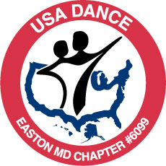
USA DANCE EASTON MD CHAPTER #6099

DANCE

BALLROOM – LATIN – SWING - COUNTRY WESTERN - HUSTLE & MORE

SPECIAL EVENT—FUNDRAISER FOR STORM VICTIMS

Your generous donation will be given to the American Red Cross

YMCA of the Chesapeake, 202 Peachblossom Road, Easton, MD.

.
Saturday, December 1, 2012

7:15pm-8:00pm— WALTZ lesson with VALENTINE HODGMAN
( Lesson included with price of admission)
8:00pm-10:00pm—Dancing to music by DJ Aggie Beletsky

TICKETS SOLD AT THE DOOR
$12.00 General Admission
$10.00—USA Dance Members, YMCA Members and under 21
$2.00 from every admission fee will be donated
(Join USA Dance on the night of the dance and your admission will be free).


Show your support…..wear something red or white

Couples, Singles, Dancers of all levels WELCOME
Dressy casual attire. Smoke and alcohol free.
Ladies, no street shoes with spike heels, please

More info: www.usadanceeastonmd.com E-mail: eastondance6099@gmail.com Call Dotty 410-822-4320
A non profit organization—501c3 (revised 11-05-12)

